Dietitian App™ Food Diary
  - Client User Guide
Manual version 1.0
Updated August 2026
Reflects current Dietitian App Production functionality.
For clients recording and sharing a Food Diary. This guide contains no clinician-only workflows.
  - Dietitian App™

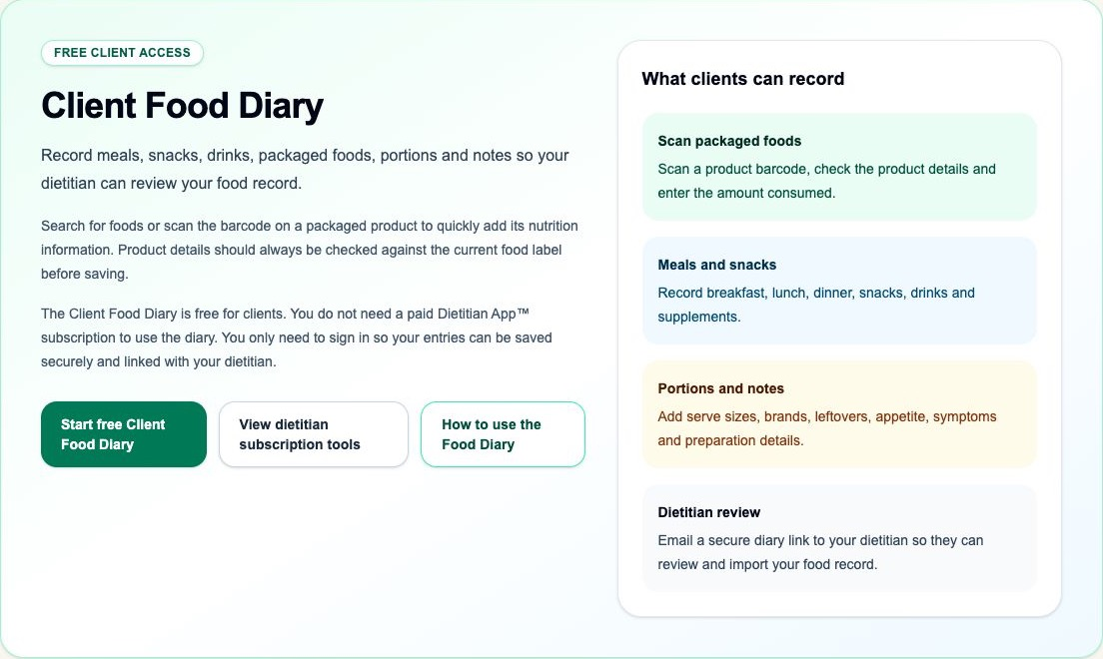
Client Food Diary signed-out home. Synthetic capture; no account or clinical data is shown.

Document status and scope
This source describes the Client Food Diary available in Production on 9 August 2026. It is written for clients and contains no clinical or technical setup instructions. Each feature is marked as one of:
- Current Production — available now.
- Current but limited — available now with the stated limitation.
- Planned — not currently available and not part of the instructions.
The Food Diary helps you record what you ate and drank and securely share a snapshot with your dietitian. It supports dietetic review; it does not diagnose, provide emergency advice or replace advice from your healthcare team.

1. What the Food Diary is for
Feature status: Current Production
Use the Food Diary to record foods, drinks, nutrition products, portions and notes over one or more days. It can calculate nutrients when a food has suitable nutrition information and a reliable portion. Your dietitian can import a shared snapshot into Nutritional Analysis.
The client diary is free to use. You need a signed-in account so entries are saved securely, but you do not need a clinician subscription.

2. Sign in and create your profile

Sign in
Feature status: Current Production
- Open the Client Food Diary and select Start free Client Food Diary.
- Enter your email address and select Send sign-in code.
- Check the inbox for that address, including Junk or Spam.
- Enter the six-digit code in the app. Use the most recently requested code.
- After successful sign-in, the app returns you to the requested page.
Never share a sign-in code. A code is intended for one sign-in and may expire.

Create the Food Diary profile
Feature status: Current Production
- Select Create food diary profile if no profile exists.
- Enter a name or profile label that helps you recognise the diary.
- Check the country or region, locale and time zone.
- Choose an energy display: kJ, kcal, or kJ and kcal.
- Choose Metric or US customary display units.
- Optionally enter your dietitian's email address. Check it carefully.
- Select Create food diary profile.
Current limitation: one consumer profile is supported per signed-in account. Deleting the profile also deletes its saved diaries and entries after a warning; this cannot be undone.

3. Select a diary date and meal occasion

Diary dates
Feature status: Current Production
- Choose the date on which the food or drink was consumed.
- Add entries for that date.
- Change the date to enter another day or review earlier entries.
The app preserves the selected local calendar date. It does not currently record an entry time or allow you to choose the first day of the week.

Meal occasions
Feature status: Current Production
Choose the closest displayed occasion for each entry:
- Breakfast
- Morning snack
- Lunch
- Afternoon snack
- Dinner
- Supper
- Drink
- Other
Use Drink for drinks outside a meal and Other when none of the other labels fits. Related snack labels may be grouped together when the diary is reviewed. You cannot create a custom occasion name.

4. Find the correct food

Search
Feature status: Current Production
- Type at least two characters of the food, product or brand name.
- If useful, choose a source filter such as everyday foods, United States foods, enteral/oral/formula products, or saved product labels.
- Review the food name, source, category, preparation, available portion and any completeness warning.
- Select the result that best matches what was actually eaten.
Search results are ranked for relevance; they are not an exhaustive browse list. Similar names can describe different preparations. Check carefully.

Understand the source labels
Feature status: Current Production
- Everyday food / AUSNUT: Australian food-composition data. Choose the food description and preparation that match the food eaten.
- USDA Foundation: United States foundational food-composition records.
- USDA FNDDS: United States foods and dishes used in dietary survey data.
- Enteral, oral and formula product / Formulary: clinical nutrition products with product and preparation information.
- Saved product label: a previously stored packaged-food label record.
- Barcode product: product information returned from the printed barcode, generally supplied by Open Food Facts.
- Clinician-created food: may appear only when an applicable private food exists for the signed-in account. The Client Food Diary does not provide a screen for clients to create or manage these foods.
Current limitation: USDA Foundation and FNDDS are available; USDA Branded Foods are not. Some foods have partial nutrient profiles.

If the food is not found
Feature status: Current Production
- Try a shorter or more general name.
- Try the brand, main ingredient or preparation method.
- Change the source filter back to All.
- Use barcode lookup for a packaged food.
- After a zero-result search, use Couldn't find this food to send a privacy-safe missing-food request.
- If necessary, record a clear free-text description and amount. Tell your dietitian that it may not be included in calculated nutrients.
A missing-food request records search demand; it does not immediately add the food to the database.

5. Scan or enter a barcode

Camera scan
Feature status: Current Production
- Select Scan barcode.
- Allow camera permission when your device asks.
- Hold the printed barcode inside the scanner view in good light.
- When a product appears, compare its name, brand, package, serving and nutrition values with the current packet.
- Select This matches my packet only when they agree.
- Choose the amount consumed and save the entry.
Barcode information can be incomplete or outdated. The current packet is the information to check. Camera availability depends on the device, browser and permission settings.

Manual barcode entry
Feature status: Current Production
- Enter only the digits printed under the barcode.
- The app accepts common retail codes containing 8, 12, 13 or 14 digits.
- Select Find and verify the returned product against the packet.
- If it is wrong, do not confirm it. Search manually instead.
An unrecognised barcode does not create calculated nutrient values.

Nutrition-label foods
Feature status: Current but limited
Scanned and saved product-label foods can be selected when the displayed record matches the packet. Only nutrients present in the source label are available. The client screen does not currently contain a full manual nutrition-label editor. Free text by itself is not a nutrient panel.

6. Choose the portion and amount
Feature status: Current Production
After selecting a food, choose either a verified source measure or a direct amount. The available choices depend on the food.

Direct amounts
- Grams (g): use for weighed solid foods.
- Millilitres (mL): use for measured liquids or prepared feed volume.
- Ounces (oz) and pounds (lb): available in the amount selector, with US mode placing these choices first for solid foods.
- US fluid ounces (US fl oz): available for liquids.
- Cups, tablespoons and teaspoons: use only when the selected food has a reliable mass, volume or density conversion.
- Serving: use when a verified serving size exists.
Enter whole or decimal quantities as needed, for example 1, 0.5 or 1.5. For a source measure, enter the number of those measures. The app shows the verified grams and/or millilitres when available.

Pieces and items
Feature status: Current but limited
Pieces, slices, items, scoops and similar wording appear only when the source provides a verified measure. They are selected as source measures rather than a universal “piece” unit. If no suitable measure exists, use weighed grams or a reliable label serving.

Metric and US display
Feature status: Current Production
Metric mode prioritises g and mL. US mode prioritises oz, lb and US fl oz. Cups, tablespoons, teaspoons, servings, g and mL remain available where appropriate. Changing display mode converts at the screen boundary; it does not change the underlying saved grams or millilitres. Source-provided measure text may remain in its original wording.

When an amount cannot be converted
Feature status: Current but limited
A free-text amount may be saved for context, but the app marks it as excluded from nutrient analysis if it cannot resolve a reliable mass or volume. Replace it with grams, millilitres or a verified source portion when possible.

7. Add, review, correct or delete an entry

Add an entry
Feature status: Current Production
- Select the diary date and meal occasion.
- Search for and select the food, or verify a barcode product.
- Enter the quantity and choose the portion or unit.
- Add useful notes such as preparation, brand, leftovers, appetite or symptoms. Avoid unnecessary identifying information.
- Review the calculated amount and warning.
- Save the entry.
- Confirm it appears under the correct date with its nutrient summary or an explanation that it is not included in analysis.

Correct an entry
Feature status: Current but limited
There is no in-place Edit button in the current Client Food Diary. To correct a food, portion, date or note:
- Check the replacement information first.
- Delete the incorrect entry.
- Add it again with the correct information.

Delete an entry
Feature status: Current Production
- Find the entry under the correct date.
- Select Delete on that entry only.
- Check that the daily list and totals update.

8. Repeated meals and several diary days

Usual meals
Feature status: Current Production
- Record each food or ingredient as a separate diary entry under the same meal occasion. A Usual Meal can combine everyday AUSNUT foods, USDA foods, Formulary products and verified barcode foods.
- Under that populated occasion, select Save this meal as a Usual Meal.
- Enter a clear template name, review the foods to include and save the template. The original meal occasion becomes its default.
- Later, find the template under Usual meals and select Add to diary.
- Choose the target diary date and meal occasion. The selected target date is used for every newly created entry. Review quantities and portions, and remove or adjust any food as needed.
- Select Add N foods to diary. Every component is added as a normal, independent diary entry with its own food/source identity and saved nutrient snapshot. The diary opens the target date so you can review the entries.
Prepared-volume products retain mL where appropriate (or US fl oz in US mode). Recheck quantities whenever you change display units.
Editing a Usual Meal template does not change earlier diary entries. Deleting a Usual Meal template does not delete earlier diary entries. Later template changes also do not alter a dietitian's previously imported, saved analysis.
Usual Meals are private to the profile. There is no shared template library.

Favourites and recent foods
Feature status: Planned — not currently exposed
The current client screen has no visible favourites or recent-food controls. Use search or usual meals instead.

Record several days
Feature status: Current Production
- Finish the entries for the first date.
- Change the diary date.
- Record every food, drink and nutrition product for the next date.
- Repeat for the number of days requested by your dietitian.
- Revisit each date to check for missed drinks, snacks, supplements, sauces, feeds and leftovers.
Daily totals are shown for the selected date. Completeness depends on the quality of every included food record; a total is not proof that the diary is complete.

9. Understand nutrient information

Energy display
Feature status: Current Production
Your profile can show energy as kJ, kcal, or both. This changes the display, not the stored meaning of the food. Carbohydrate, protein and fat remain in grams.

Zero is different from unavailable
Feature status: Current Production
- 0 means the source supplied a genuine numeric zero for that nutrient.
- Unavailable, blank, partial profile, or Not included in nutrient analysis means the app does not have suitable information. It must not be interpreted as zero.
If one or more foods lack a nutrient, a total for that nutrient may be unavailable. Do not use an incomplete total to decide that intake is adequate or inadequate without your dietitian's review.

10. Nutrition products and formula

Enteral feeds and oral nutrition supplements
Feature status: Current Production
- Search by product or brand.
- Choose the exact Formulary product and preparation.
- Check whether the nutrient basis is per serve, per 100 mL or per 100 g.
- Record the amount actually consumed, not merely the amount offered.
- For ready-to-drink products, use the consumed volume or verified container serving.

Infant and paediatric formula
Feature status: Current but limited
Choose the exact product and standard preparation shown. Record the prepared volume consumed when nutrients are based on prepared feed. If recording powder, use a verified scoop or gram measure only when the source provides it. Do not enter powder grams as though they were prepared millilitres.
The app supports recorded standard preparation information. It does not currently calculate a custom or non-standard concentration from powder, water and final volume. Ask the dietitian how to record a non-standard preparation.
Unavailable product micronutrients remain unavailable rather than zero.

11. Share with a dietitian

Send a share
Feature status: Current Production
- Review every intended diary date and entry.
- Enter or confirm the intended dietitian's email address.
- Select Email diary.
- Wait for the success message. If it fails, do not repeatedly send without checking the address and connection.
- Tell the dietitian which dates the diary covers.
The email contains a secure, tokenised import link. Send it only to the intended clinician.

What happens next
Feature status: Current Production
The dietitian opens the link, verifies the intended patient, imports the diary once, reviews it and saves a clinical analysis. Your original diary remains in your account. Later changes to your diary do not silently alter the clinician's imported snapshot.
A single share cannot be imported twice, including two imports attempted at the same time. If the diary needs to be sent again after changes, create another deliberate share. Sending another share does not delete your diary.

12. Privacy and security
Feature status: Current Production
- Use only your own account and a trusted email inbox.
- Never share a sign-in code.
- Check the clinician's email before sharing.
- Treat a diary share link as private.
- Record only information needed for dietetic care.
- Sign out or secure the device after use.
- Do not use the diary for urgent medical communication.
- Profile deletion is permanent and removes the profile's saved diaries and entries after confirmation.
Access to the diary is account-scoped. The share link permits the controlled clinician import workflow; it is not a public diary page.

13. Troubleshooting

Food not found
Feature status: Current Production
Try a shorter name, brand, preparation or different source filter. Return the filter to All, try barcode lookup, or submit the privacy-safe missing-food request. A free-text fallback may be saved but can be excluded from analysis.

Barcode not recognised or wrong product
Feature status: Current Production
Check all digits, lighting and camera focus. Try manual lookup. If the result does not match the current packet, reject it and use search or a free-text note. Do not use another product merely because the barcode looks similar.

Camera permission
Feature status: Current but limited
Allow camera access in the device or browser settings, reload the page and try again. If the device still cannot provide a camera stream, use manual barcode entry. Camera behaviour depends on device and browser support.

Incorrect portion
Feature status: Current but limited
Delete and recreate the entry. Prefer a verified source measure, grams or millilitres. Check decimal placement and distinguish solid ounces from US fluid ounces.

Missing nutrition information
Feature status: Current Production
Read the completeness warning. Try a fuller source record that still matches the food. If none exists, retain the accurate food description and tell the dietitian; never replace “unavailable” with zero.

Unable to share
Feature status: Current but limited
Check the clinician email, internet connection and displayed error. Retry once after correcting the cause. Email delivery depends on the mail service. Ask the clinician to check Junk or Spam if the app reports success but no email arrives.

Login-code problem
Feature status: Current but limited
Check the entered email, Junk or Spam, and use the newest code. Codes expire and are single-use. Request a new code if necessary. Never paste a code into a message or give it to another person.

14. Quick-reference checklist
Feature status: Current Production
Before sharing, check that you have:
- recorded the correct calendar dates;
- included breakfast, lunch, dinner, snacks, supper, drinks and other extras;
- recorded water, alcohol, supplements and nutrition products when relevant;
- selected the closest matching food and preparation;
- checked barcode products against the current packet;
- used a reliable portion, gram or millilitre amount;
- recorded the amount consumed rather than only the amount served;
- described leftovers, recipes, brands or preparation where helpful;
- kept genuine zero separate from missing information;
- reviewed every day for omitted items;
- confirmed the dietitian's email address before selecting Email diary.

Planned / Future Development — Not currently available
Feature status: Planned
The following roadmap items are not part of the current Food Diary:
- USDA Branded Foods search strategy;
- UK CoFID, Canadian Nutrient File and New Zealand FOODfiles;
- visible favourites and recent foods;
- in-place diary entry editing;
- structured manual nutrition-label entry;
- optional entry time, additional daylight-saving/time-zone handling and a configurable first day of week;
- further mobile, scanner-permission, offline/error and accessibility work;
- richer usual-meal templates and offline capture;
- custom or non-standard formula concentration calculation;
- explicit reanalysis against a newer food-data version;
- food-source update/version-management tools;
- improved missing-food status and feedback;
- scientifically verified mapping for currently incompatible nutrient definitions;
- additional reports and exports.
Planned items must not be relied on until they have been implemented, reviewed and released.

